CHAPTER THREE
DESIGN METHODOLOGY

3.1 OVERVIEW OF THE PROPOSED SYSTEM
At this stage, the information gathered were analyzed and restructured into a more relevant and useful data. Data analysis and restructuring was based on the identification of the basic needs and the structure required for the project. The information gathered were that the analyzed and restructured in such a way that the subsystems and the modules were achieved efficiently. The analysis and restructuring of these data were such that the system is capable of presenting one frame at a time to the user.
This Screen-class system is a system that has some learning facilities, which aids the learner in using the package. It also contains facilities for test of knowledge. The subsystems and the module in this software were integrated to make up the topic itself.

3.1.1 METHOD OF DATA COLLECTION
Having achieved the software requirements, the next step was to source for information relative to the subject. This process of information gathering was achieved through so many sources including:
- File downloads from the Internet
- Textbooks in the library
- Newspaper, Journals and articles
- Other publications
- Personal observations.

3.1.2 OBJECTIVE OF THE EXISTING SYSTEM
The objective of the system is to develop an online lecture and evaluation system that will aid in online teaching to students.

3.1.3 INPUT ANALYSIS
The input to the new system is student’s login form, student’s forum dialogue space, question setting form, and answer form. These forms are captured online and contain details of the user, the questions and answers.

3.1.4 PROCESS ANALYSIS
The answer supplied by the user is processed by accessing their scores, and storing it on the database and the class forum with is interactive in nature.

3.1.5 OUTPUT ANALYSIS
The output from the system is the scores of the test and the reply to questions in the class forum. The screen-class system also forms part of the output.

3.1.6 PROBLEM OF THE CURRENT SYSTEM
Without screen-class, it will be difficult for people to learn fast. Experts are not readily available, so there is need to have a knowledge based system that can be used to train students in various fields of learning.

3.1.7 JUSTIFICATION FOR THE NEW SYSTEM
Online lecture and evaluation system can provide benefits for the organizations and individuals involved. It provides students with the opportunity to learn fast and have a wide knowledge. Internet access makes learning easy, obtainable, and affordable.

3.1.8 DATA PROCESSING
Data processing involves the manipulation and processes involved in displaying the class, past question, test for the student for download. These processes start from the school administrators, follow by administrator’s (staff) to the student. All resources are uploaded to the system by the admin into the system where the student can search for a desired past question or input the details of the past question they need from the system.

3.2 SYSTEM ARCHITECTURE
Below is the application architecture which shows a graphical representation of the application, views, and database. It also shows the connections and interactions that can be carried out in the system.

Presentation Layer (Frontend)

User Interface (Web App)

Login (Authentication)

Adminstrative Portal
(Lecturers)

Student Portal

Programming Language
(HTML, CSS, JAVASCRIPT)

Data Layer
(Backend)

Store and Retrieve staff records

Store and Retrieve student records

Store and Retrieve Materials records

API’s Base

Programming Language & Database
(PHP & MySQL)

FIGURE: 1.3 SYSTEM ARCHITECTURE

3.3 SYSTEM FLOWCHART
START

START
START

SUPER ADMIN LOGIN
STUDENT LOGIN

ADMIN LOGIN

NO
LOGIN SUCCESSFUL
LOGIN SUCCESSFUL

LOGIN SUCCESSFUL

NO NO

YES YES YES
VIEW STAFF, STUDENT, FACULTY, COURSE
TAKE CLASS

ADD TOPIC, CLASS

DOWNLOAD MATERIAL

TAKE ATTENDANCE

ALLOCATE COURSE

UPLOAD MATERIAL

TAKE ATTENDANCE

STOP

FIGURE: 1.4 SYSTEM FLOWCHART
CHAPTER FOUR
SYSTEM IMPLEMENTATION AND DESIGN
  - DESIGN STANDARDS
The new system is structured to work with the standard software development procedures. It is web based and has a relational database structure for storing the various activities involved. The screen-class system is placed in PHP & JAVASCRIPT codes for online access alongside with MySQL database.

    - THE HOME PAGE DESIGN

The home page output from the system. These pages contains super administrator, administrator and student to login into their portal.

FIGURE: 4.1.1 HOME PAGE DESIGN

    - AUTHENTICATION MANAGEMENT
Every user who wants to use this software (screen-class) by means of email address and password which is already created by the super administrator and is stored in the database. This authentication module can only access administrator and student who has register under administrator portal. This authentication form is required email as username and password.

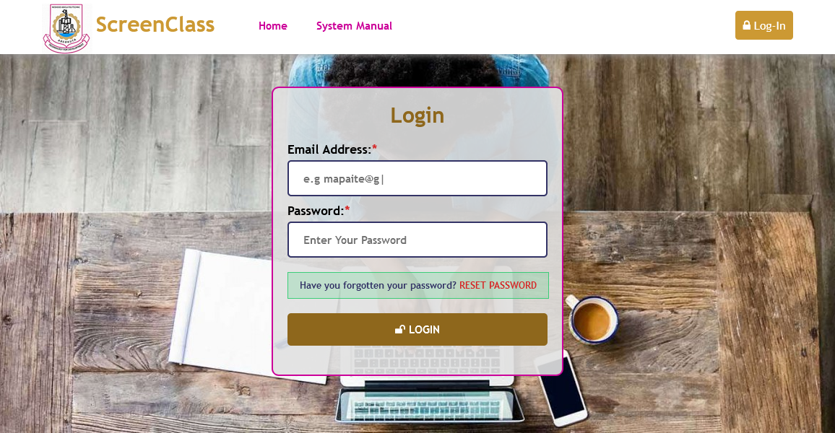

FIGURE: 1.6 AUTHENTICATION MANAGEMENT

4.1.3 THE ADMIINSTRATOR’S DASHBOARD PORTAL
The super administrators are the back-end of the software, they are the one who manage and manipulate every module in this page. They can register administrators as (staff), students, add departments, add courses. Also they can assign course for staff and manipulate staff (update staff profile) and (update student profile).

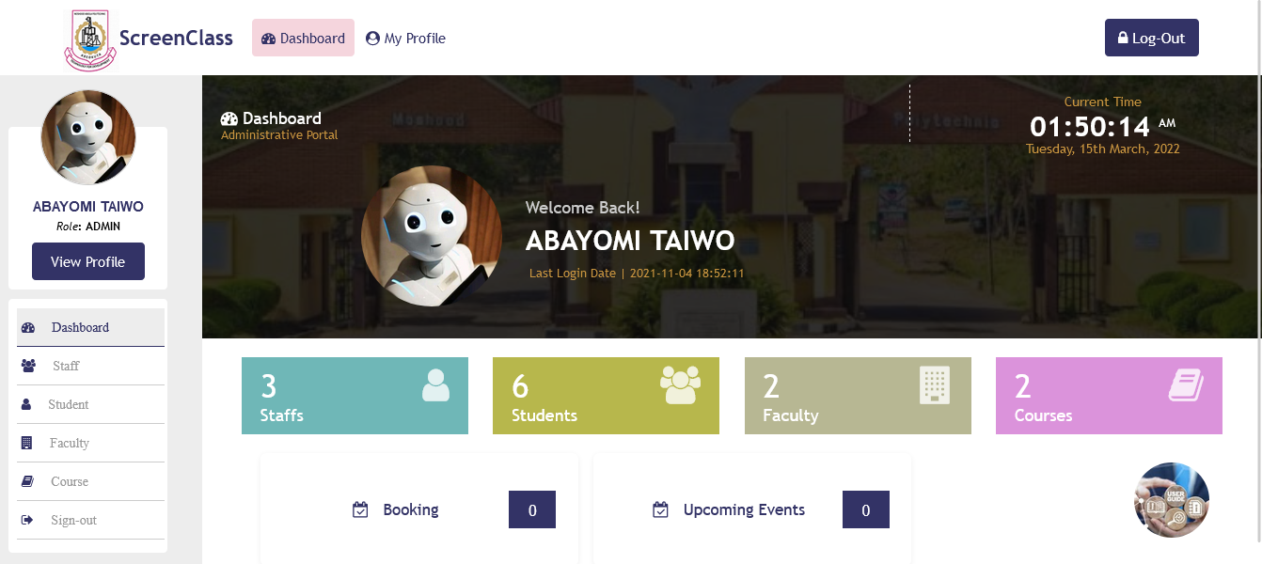

FIGURE: 1.7 SUPER ADMINSTRATOR’S DASHBOARD

4.1.4 ADMINSTRATOR’S REGISTRATION
Any administrators, student want to make use of this software (screen-class) he/she must register under super administrators. Every registration automatically the system will generate identity no for administrators (staff id no) and student (matric no) so that the system can count number of administrators and student that are registered.
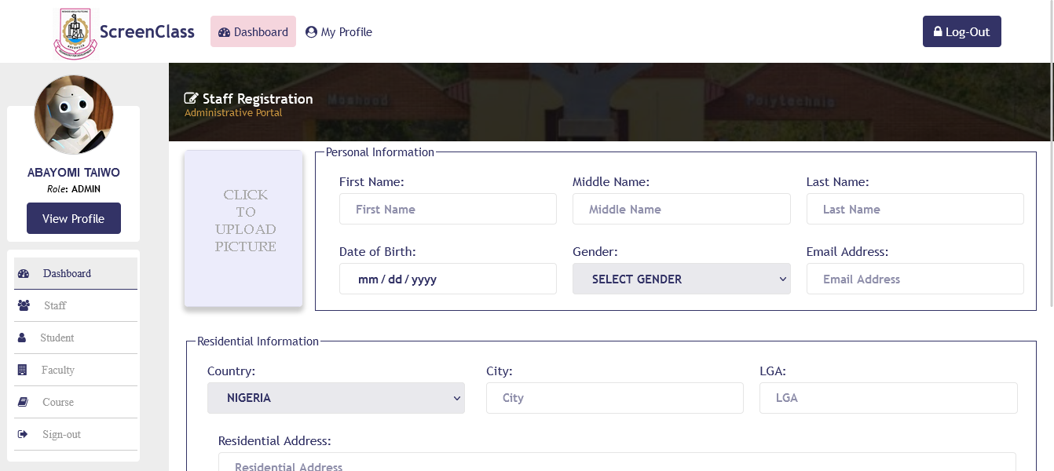

FIGURE: 1.8 ADMINSTRATOR’S REGISTRATION
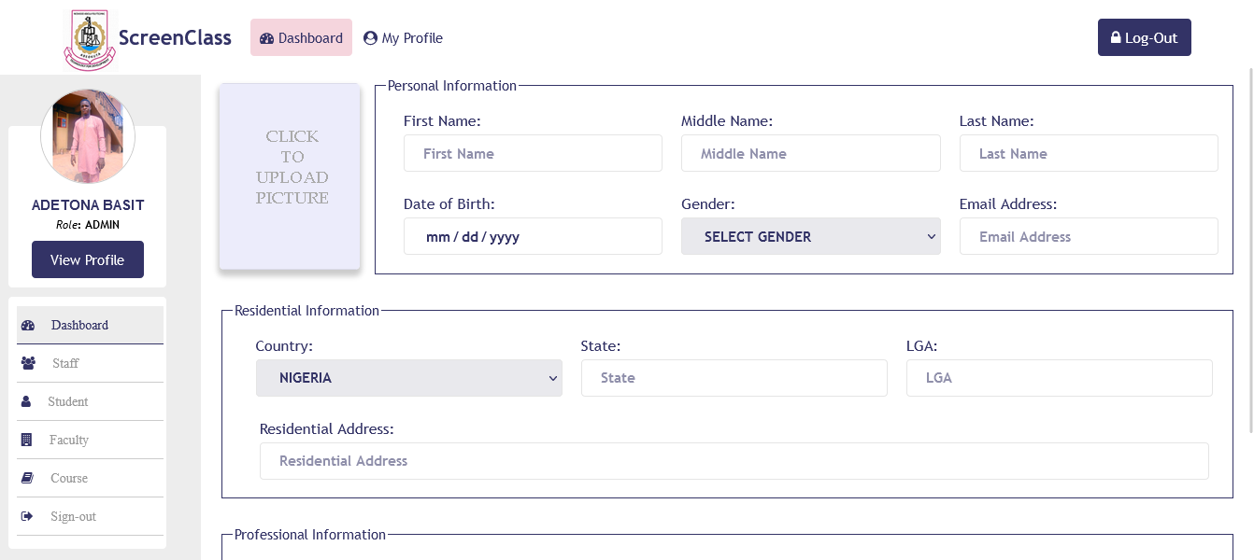

FIGURE: 1.9 STUDENT REGISTRATION

4.1.5 THE ADMINSTRATOR’S DASHBOARD PORTAL
The Administrator’s portal are staff that are registered under super administrators. The software carry operation like, registered administrators (staff) can view students, add class, take lecture, and as well, it can upload materials for students and take student attendance.

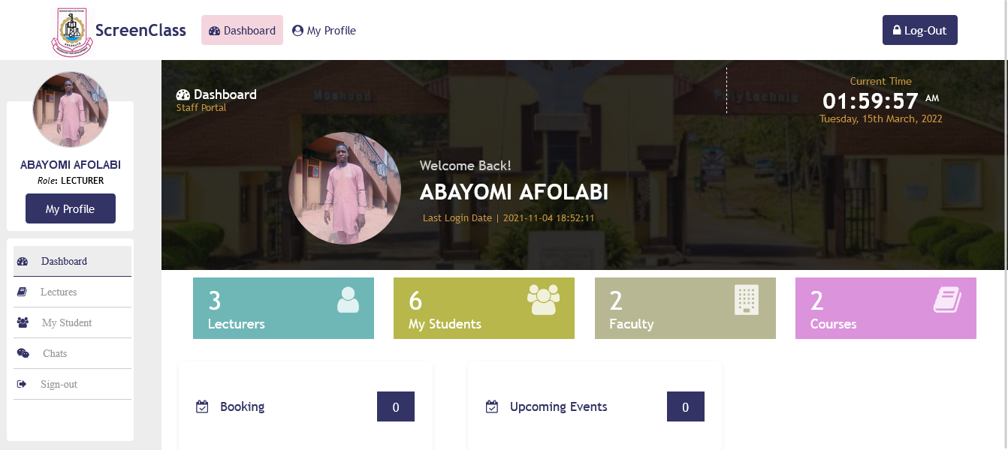

FIGURE: 1.10 ADMINSTRATOR’S DASHBOARD
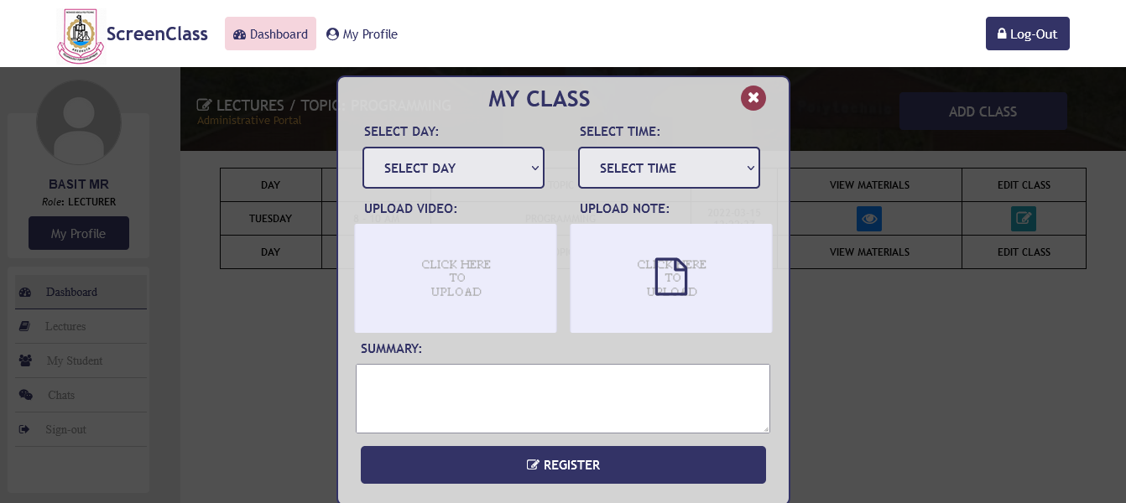

FIGURE: 1.11 ADMINSTRATOR’S CLASS

4.1.6 THE STUDENT DASHBOARD PORTAL
A student that has registered under school administrators (super administrators) can only access and login to his/her portal. In this dashboard, student can take class if super administrators has assign course for any of the lecturer (staff) and can allow to take class for the student.
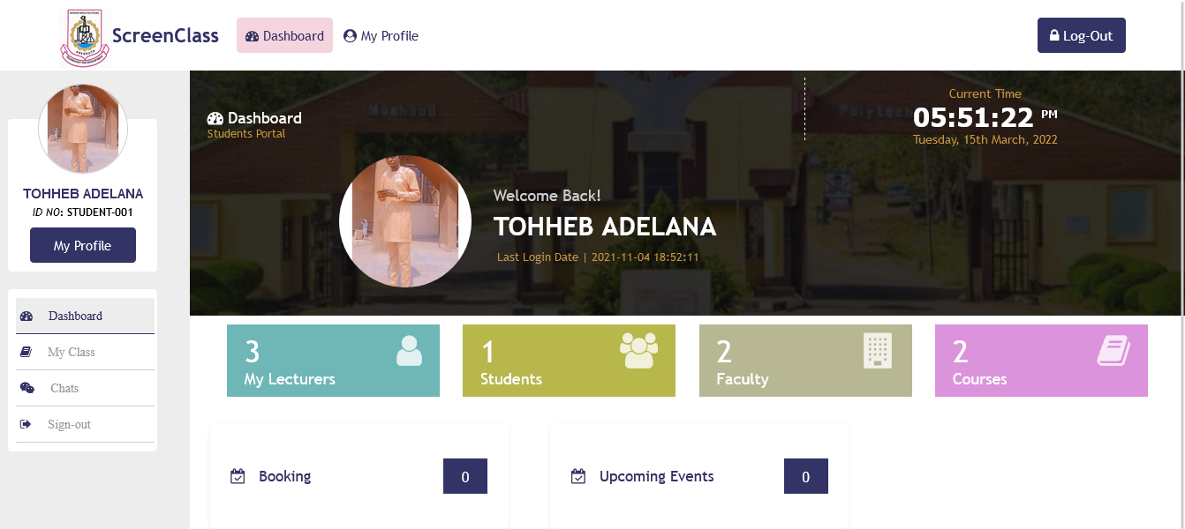

FIGURE: 1.12 STUDENT DASHBOARD

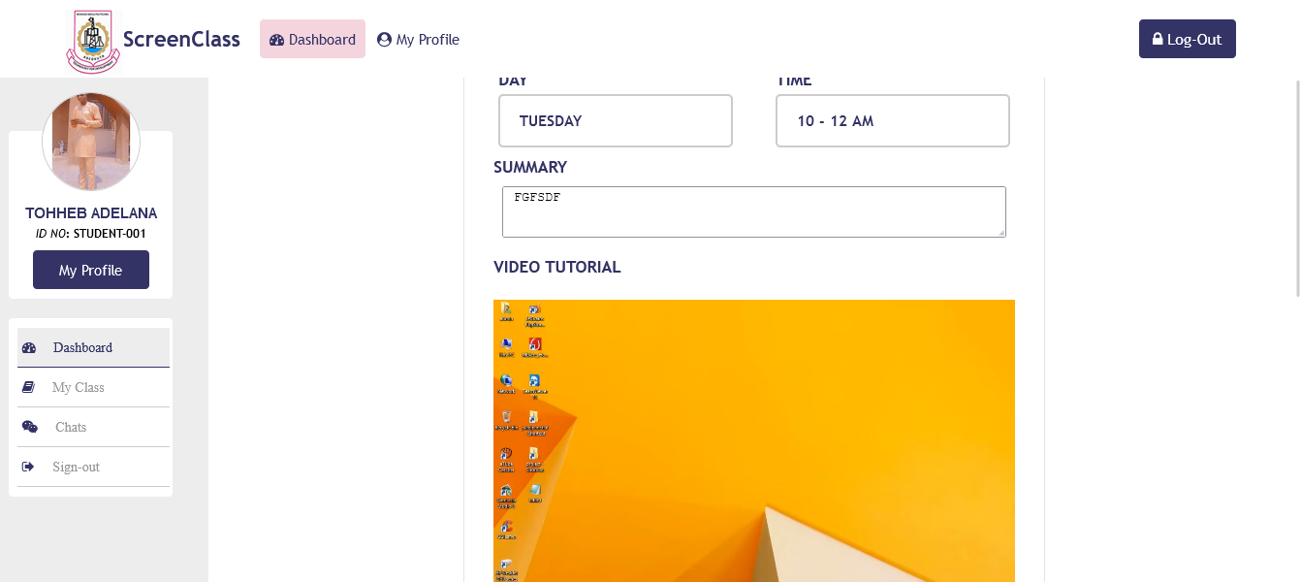

FIGURE: 1.13 STUDENT DOWNLOADABLE MATERIALS

4.1.7 DATABASE DESIGN
MySQL database was used in the design. There are ten tables used in the design. The student table, staff table, course table, department table, faculty table, counter table, lectures table, week table, status table, period table.
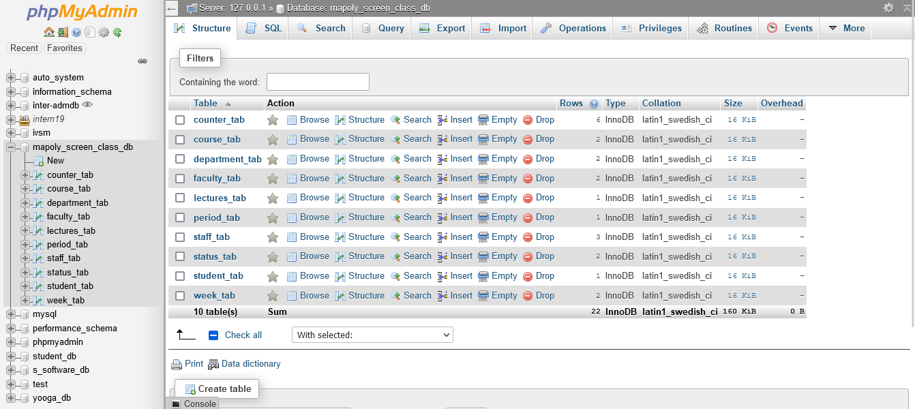

FIGURE: 1.14 DATABASE DESIGN

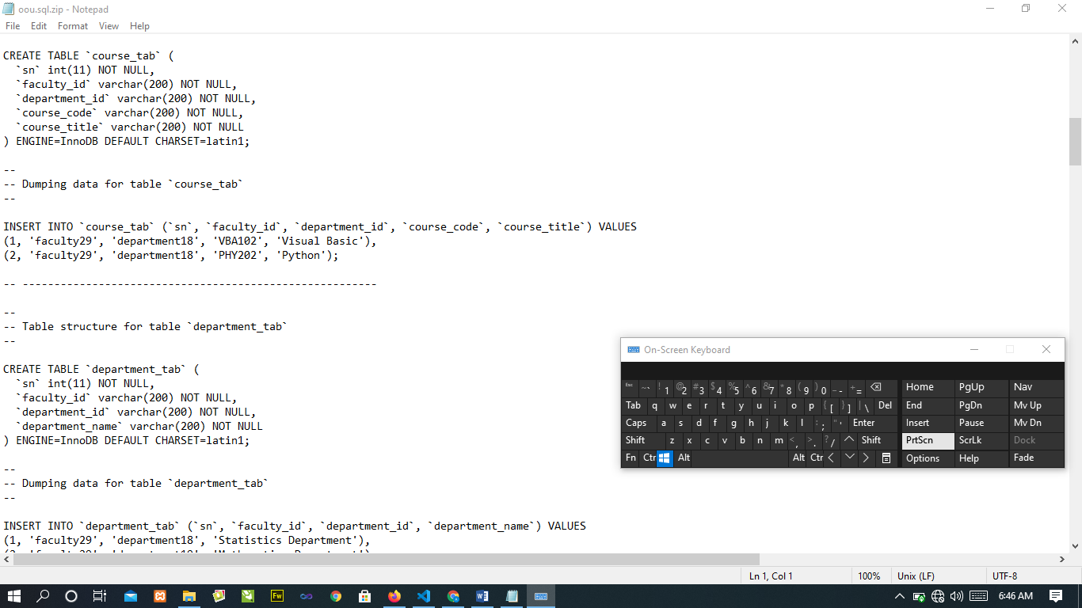

FIGURE: 1.15 MYSQL DATABASE DESIGN

4.2 SYSTEM REQIREMENT

Hardware Requirements

In the design, the software developed needs the following hardware for an effective and efficient operation of the new system.

Intel Computer System.
- At least 2GB RAM.
- Enhanced keyboard.
- At least 320GB hard disk.
- A colored monitor.
- An uninterruptible power supply (UPS) units
- LaserJet or DeskJet printer.

Software Requirements
The software requirements include: -
1. A window XP or higher version for faster processing
- Database server (apache)
- Web server (apache)
- Graphical application (Corel draw)
- Dreamweaver 8.0
- Mozilla web browser
- Fire Fox web browser
- Chrome web browser

Operational Requirement
For the new system to be operational, Internet access is needed in the computer.
Personnel Requirement
A Computer system with internet access.

CHAPTER FIVE
SUMMARY, CONCLUSION AND RECOMMENDATIONS
5.1 SUMMARY
Having come to the completion of the project work, a lot of achievements was made and they include:
- Design and development of a school online lecture and evaluation system.
- To view list of administrator’s and student was also design.
- Question setting system was also designed.
- To add faculty, department, course, class was also design.
- To upload and view downloadable materials was also design
- Answer system was equally designed to enable the students supply their answers to questions.
- The use of PHP, JAVASCRIPT, CSS codes to design a web application.
- The use of a database server was implemented.

5.2 CONCLUSION
With the advent of information technology in our developing and developed world, learning facilities are now on the increase. Also means of accessing the understanding rate is also fast increasing. Therefore, the online lecture and evaluation system as developed in this project will assist the users to test the knowledge of people around.
This adds a lot of advantage to the communication / training institutes as a package like this can be used to train the students online and test their knowledge and also adds value to education standard as it reduces examination malpractices.

5.3 RECOMMENDATION
Online lecture and evaluation system is recommended to all who wants to be educated especially at the tertiary level as it is effective and of high standards.

REFERENCES

A, B. (2005). e-Learning and Distance Education. London: Oxford university press.
Allen, I. a. (2009). Online Education in the United States. New Jersey. Wiley publishing.
Edward. (2000). E-Learning Designing. Brussels: Sams publishing.
Graziadei. (1993). Virtual Instructional Classroom Environment in Science (VICES). Atlanta: Hila press.

Harasim, L. (1995). A Field Guide to Teaching and Learning Online. Cambridge: MIT Press.

Hebert. (2007). Five Challenges and Solutions in Online Music Teacher. London: Oxford university press.

Hiltz, S. (1990). Evaluating the Virtual Classroom. New York: St. Martin’s press.

Karrer, T. (2008). Corporate Long Tail Learning and Attention Crisis. California: Sun Microsystems, Inc.

Kerkman, L. (2004). Convenience of Online Education Attracts Midcareer. Students. Cambridge: MIT Press.

Mason. R, a. K. (1989). Computers and Distance Education. London: Oxford university press.

Means, B. T. (2009). Evaluation of Evidence-Based. Practices in Online Learning. USA: McGraw Hill companies.

Allen, I. and Seaman, J. (2009). Online Education in the United States. New Jersey: Wiley publishing.

Allen, I. and Seaman, J. (2003). The Quality and Extent of Online Education in the United States. New Jersey: Wiley publishing.
Bates, A. (2005). e-Learning and Distance Education. London: Oxford university press.
Edward, C. (2000). E-Learning Designing. Brussels: Sams publishing.
A cademy, S. (2013). Post-Utme-Questions-Answers-Baze-University. Samphina academy.

Academy, V. (2009). The History of Online Schooling. Visual Academy.
Connection’s. (2016). Main Benefits of Online School . Connection’s Academy.
Docsity. (2013). Exam Study and Advantages of Exampapers. Docsity.
James, A. (2014). Automated Students Management System. Oracle.
K., A. S. (2012). Student Management System.
Ngoma, S. (2019). Effectiveness of PastQuestion.
point, T. (2016). Tutorials point. Retrieved from https://www.tutorialspoint.com/sdlc/sdlc_agile_model.htm.
S., W. S. (2014). A Framework for Web-based Past Question System.
Spinuzzi, C. (2015). The methodology of participatory design. Technical communication.
UNESDOC. (2016). Digital Library. UNESDOC.
University, B. (2019). Exam Past Questions. Baze University.
University, N. e. (2020). Benefits of Online Learning. North eastern University.
Vecchioli, L. (2018). A Process for Evaluating Past Question.
Wayman, J. S. (2015). Software Enabling School Improvement through Analysis of Student Data.

Harasim, L. Hiltz, S. et al (1995). A Field Guide to Teaching and Learning Online. Cambridge: MIT Press.

APPENDIX
HOME PAGE SOUCE CODE

<!DOCTYPE html>
<html>
<head>
<title>MAPOLY - ScreeClass</title>
<?php include 'reference.php' ?>
</head>
<body>
<?php include 'header.php' ?>

<div class="background-image-div">
<?php include 'slide.php' ?>
</div>

<footer>
<div class="overlay-div animated animated zoomIn animated">
<a href="login.php"><button class="main-btns no-right">ADMIN</button></a>

<a href="login.php"><button class=" btn-cl">SUPER ADMIN</button></a>
<a href="login.php"><button class="main-btns no-right">STUDENT</button></a>
</div>
</footer>

</body>
</html>
ADMIN PAGE SOUCE CODE

!DOCTYPE html PUBLIC "-//W3C//DTD XHTML 1.0 Transitional//EN" "http://www.w3.org/TR/xhtml1/DTD/xhtml1-transitional.dtd">
<html lang="en" xmlns="http://www.w3.org/1999/xhtml">
<head>
<?php require_once ("reference.php")?>
<title>Administrative Portal | MAPOLY - ScreenClass</title>

</head>
<body
<?php include 'header.php' ?>
<div class="dashboard-main-div">
<?php include 'admin-reference.php' ?>
<div class="right-sided-div">
<div class="bg-image-div">
<div class="bg-cover">
<div class="dashboard-overall">
<div class="dashboard-admin-text">
<span class="dashboard">
<i class="fa fa-dashboard"></i>
Dashboard
</span>
<br/>
<span class="admin-portal">
Administrative Portal
</span>
</div>

<div class="current-time">
<span class="text">
Current Time
</span><br/>
<span class="time" id="datetime">
<?php echo date("h:i:s") ?> <sup> <?php echo date("A") ?> </sup>
</span><br/>
<span class="text">
<?php $date = date("l, dS F, Y");
echo $date
?>
</span>
</div>
<div class="user-details">
<div class="picture-div">
<img id="ImageDisplay" name="ImageDisplay" alt="Passport"
<?php
if ($passport == ''){
?>
src="images/po.png"
<?php
}else{
?>
src="../admin/staff-picture/<?php echo $passport ?>"
<?php } ?>
>
</div>
<div class="welcome-text">
Welcome Back!
<h1><?php echo $lastname ?> <?php echo $firstname ?></h1>
<span class="login-date"><i class="fa fa-clock"></i>
Last Login Date
<span> | </span>
2021-11-04 18:52:11
</span>
</div>
</div>
</div>
</div>
</div>
<div class="main-displayed-div">
<a href="staff-list.php"><div class="main-div-proper staffs">
<div class="inner-div">
<?php
$staff_count_query = mysqli_query ($conn,"SELECT * FROM `counter_tab` WHERE counter_id='STAFF'") or die ('cannot select staff table');
$staff_count=mysqli_fetch_array($staff_count_query);
$staff=$staff_count['counter_value'];
?>
<i class="fa fa-user"></i>
<span class="number">

<?php echo $staff ?>
</span><br/>
Staffs
</div>
</div></a>
<div class="main-div-proper students" onclick="_view_student()">
<div class="inner-div">
<?php
$staff_count_query = mysqli_query ($conn,"SELECT * FROM `counter_tab` WHERE counter_id='STUDENT'") or die ('cannot select staff table');
$staff_count=mysqli_fetch_array($staff_count_query);
$student=$staff_count['counter_value'];
?>
<i class="fa fa-users"></i>
<span class="number">
<?php echo $student ?>
</span><br/>
Students
</div>
</div>
<a href="faculty-table.php"><div class="main-div-proper faculties">
<div class="inner-div">
<?php
$staff_count_query = mysqli_query ($conn,"SELECT * FROM `counter_tab` WHERE counter_id='FACULTY'") or die ('cannot select staff table');
$staff_count=mysqli_fetch_array($staff_count_query);
$faculty=$staff_count['counter_value'];
?>
<i class="fa fa-building"></i>
<span class="number">
<?php echo $faculty ?>
</span><br/>
Faculty
</div>
</div></a>

<div class="main-div-proper courses" onClick="_view_course();">
<div class="inner-div">
<?php
$staff_count_query = mysqli_query ($conn,"SELECT * FROM `counter_tab` WHERE counter_id='COURSE'") or die ('cannot select staff table');
$staff_count=mysqli_fetch_array($staff_count_query);
$courses=$staff_count['counter_value'];
?>
<i class="fa fa-book"></i>
<span class="number">
<?php echo $courses ?>
</span><br/>
Courses
</div></div> </div>
</body>
</html>

